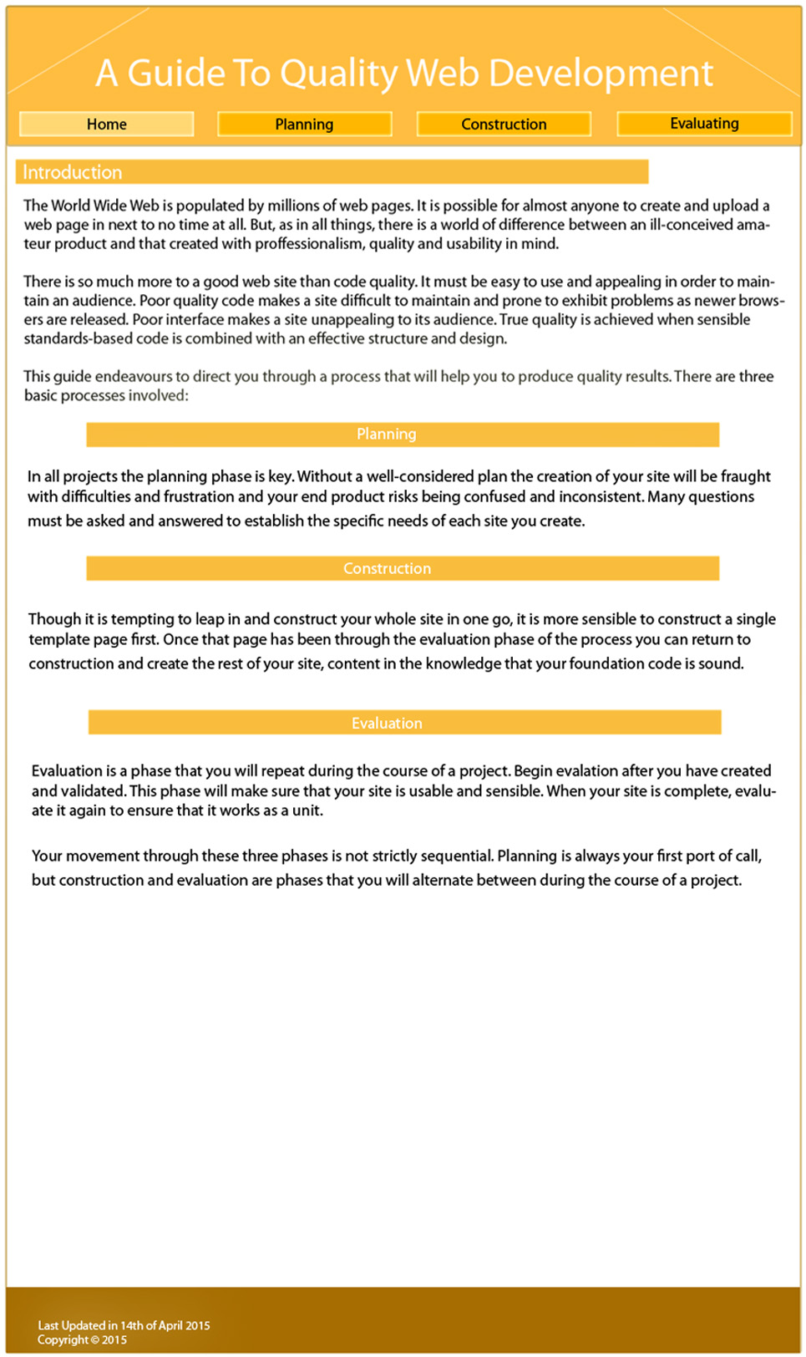

Html background colour: white,g grey, light orange, or dark orange. (optional)

Font-family: Roman times, arial, helevantica, san-serif

Font-size: 110%

Box shadow: 8px 8px 8x black

a:hover and li: hover(nav only)

colour scheme:

FFE7BB, FEF7E7, FCEAC5, F9BB3D, and white.

20px

h2 text align center, margin: auto

H1 padding:-left: 5px

All h elements: 800px

20px

Body top margin 20px

20px spacing

15px

H1 default align

h2 text align center

h2 text align center

Default position of footers

Click to read more

Click to read more

Click to read more

20px top margin

40px

100px

70px

Text Justified

110px

1000px